Business/Entity Relationship – The customer and Marco
- Marco has no relationship with The customer’s Singapore team at the time of The employee's case (It was with SGET since 2020).
- Marco Singapore later signed with The customer’s Singapore team for multi-country EOR (local/foreigner) in Mar and May 2024. This is for The customer HQ running Singapore as a billing entity.
- In Nov 2023, Marco Team knows there was some issue with The customer's Singapore entity (EP Renewal cannot be done) and requires help for a China National's EP.
- In Nov 2023, Tao checked with Wen Hang on if they have tried searching for a local talent, Wen Han mentioned that they did but with no success.
- Marco team met The customer’s Singapore team on 29 Nov 2023 to understand their situation, the customer’s Singapore team mentioned that 4 EP cannot renewal due to company issue. During the meeting, Marco team did not know the exact issue with The customer’s Singapore team. SK even showed the rejection screenshot to Marco Team. Marco team discussed with SK on the potential reason of the rejection.
- All documents for The employee were sent from The customer’s Singapore team.
Employee The employee
- The employee always has a HQ Employment Contract, even during 30 Nov 2023-Feb 2024
- SK from The customer’s Singapore team was in contact with Marco team, informed The employee the arrangement in Dec 2023.
- Marco team has no contact with The employee until 10 Jan 2024. Marco team later has some communication with The employee for document clarification.
- The employee has no involvement of setting up Marco and Stone Forest, he got to know it in Dec 2023 from The customer’s Singapore team.
Local Service Delivery Partner – RSM Stone Forest
- RSM Stone Forest is Marco Singapore’s Tax Advisor since 2023, it was introduced by Clyde & Co (Marco’s legal advisor and DPO).
- RSM Stone Forest Tax Advisor recommended its staffing unit to work with Marco for Singapore Service Delivery of EOR (for both local and foreigner).
- RSM Stone Forest Staffing unit has setup a working relationship with Marco Team in June 2023 (with the understanding that RSM can do EOR for Marco in Singapore as an EA).
- RSM Stone Forest informed Marco team about the compass changes in Oct 2023
- Marco team sent out an email to Store Forest on 29th Nov 2023 asking for EOR services and described the rejections The customer’s Singapore team faced.
- Marco had a meeting with Forest at the meeting on 4th Dec 2023, Stone Forest confirmed that they can provide EOR service for The employee.
- Stone Forest signed both Master Framework agreement and SOW for The employee on 2nd Jan 2024.
Government Response
- In government’s eye (in a simple way): The customer’s Singapore team got blacklisted, went for a local contract staffing company to hire The employee, which is illegal.
- EOR vs Contract Staffing?
  - EOR Definition by Tao:
    - Legal Employer
    - Legal Employee Status (+ Related Services, such as work visa)
    - Employment Contract
    - Payroll and Benefit
    - HR Operation Support
  - EOR By MOM:
    - No Entity in Singapore (Personal opinion of the officer only. Law is hard to pass, go to MOM website for MP inquiry on EOR)
Tao’s View
- Direct vs Indirect EOR Model
- EA vs Payrolling vs AUG vs Portage
Follow up
- MOM meeting The Customer’s Management in early Feb.
- Investigation concludes in May/June 2025
Reference
- EOR Definition by MOM:
https://www.mom.gov.sg/newsroom/parliament-questions-and-replies/2023/1107-written-answer-to-pq-on-employers-of-record-and-protection-for-employees-of-eors

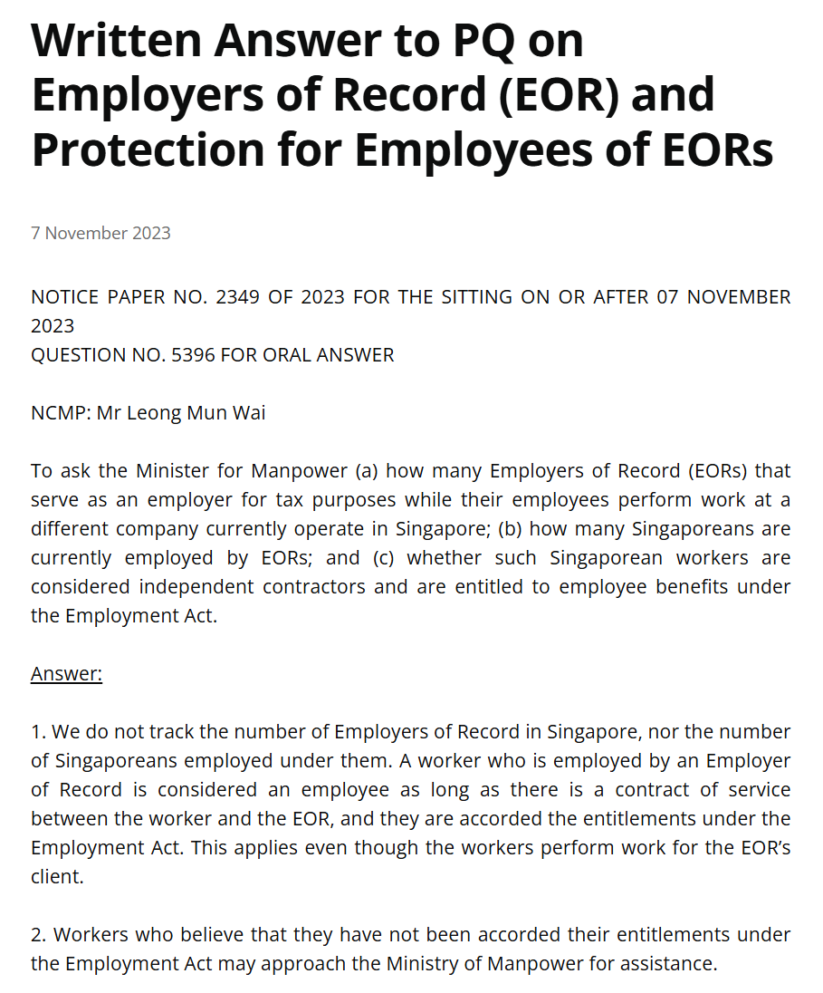

- EOR Definition by Marco:
https://marcopayroll.com/services/employer-of-record/

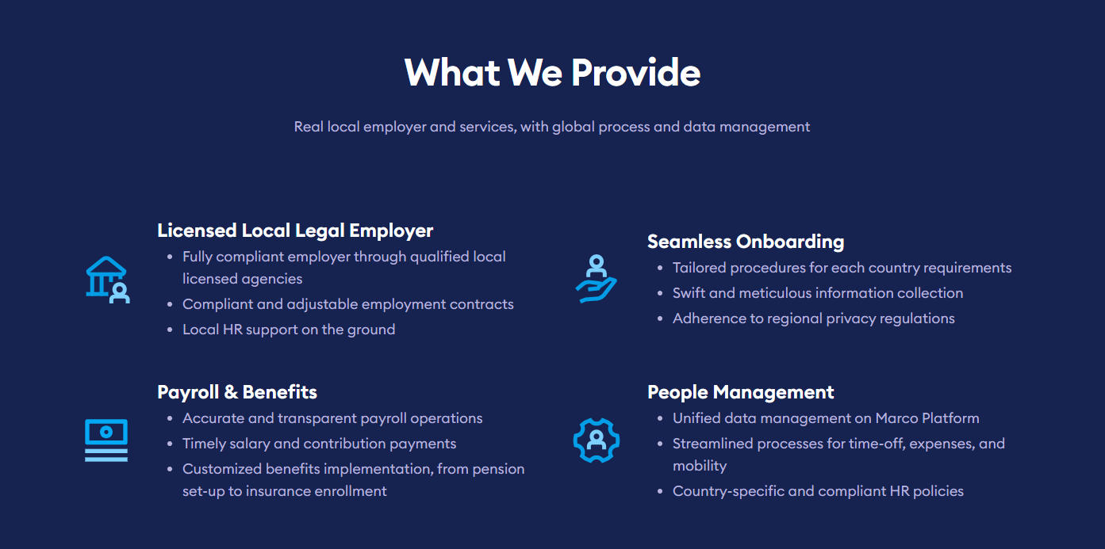

- Payrolling Definition by Netherlands Government: https://business.gov.nl/regulation/payrolling/
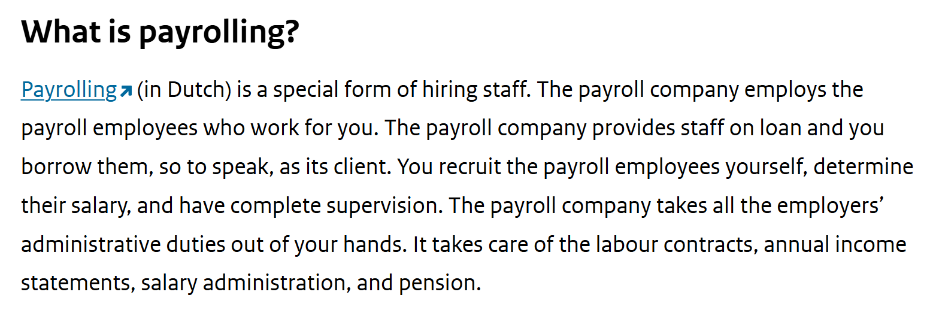

- Salary Portage Definition by France Government:
https://entreprendre.service-public.fr/vosdroits/F31620?lang=en

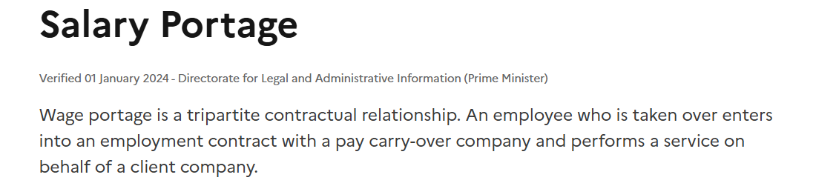

- AUG Definition by Germany Government:
https://www.gesetze-im-internet.de/a_g/__1.html

